**GPA Growth Analysis**

**Methodology**

* Used data from Fall 2017-18 and Spring 2018-19 for Class of 2021 students.
* Only included students who had GPA data entered for *both* their Fall 2017-18 and Spring 2018-19 terms

**Notes**

* After filtering for students who had complete GPA data, Denver only had 8 students included. Their data suggest a positive trend, but given the small sample size any trend should not be taken as a strong indicator of success.

**Observations**

* Ignoring Denver, Aurora, New Orleans, Sacramento, San Francisco, and Watts saw positive increases in their average GPAs.
* Aurora saw the highest growth followed by San Francisco.
* Aurora's growth was driven by a strong improvement among students who were near a 3.5 GPA in their first semester but by the end of their Spring 2018-19 term had increased their GPA above 3.5.
* San Francisco’s growth, by comparison, was driven by increasing the GPA of the students who started at College Track with a 2.5 GPA or below.

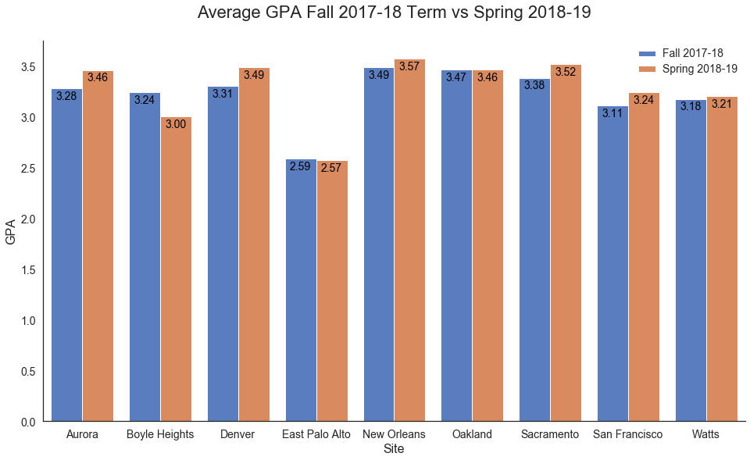

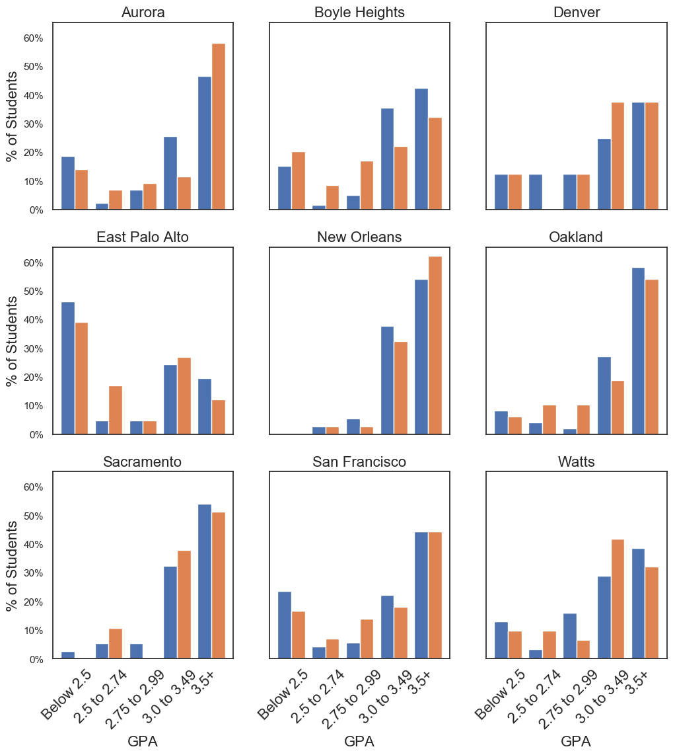

**Count of Students**

|  |  |
| --- | --- |
| Site | Count |
| Aurora | 43 |
| Boyle Heights | 59 |
| Denver | 8 |
| East Palo Alto | 41 |
| New Orleans | 37 |
| Oakland | 48 |
| Sacramento | 37 |
| San Francisco | 72 |
| Watts | 31 |
| All | 376 |

**Count of Students by Bucket**

|  |  |  |  |  |  |  |
| --- | --- | --- | --- | --- | --- | --- |
| Site | Term | Below 2.5 | 2.5 to 2.74 | 2.75 to 2.99 | 3.0 to 3.49 | 3.5+ |
| Aurora | Fall 2017-18 | 8 | 1 | 3 | 11 | 20 |
| Spring 2018-19 | 6 | 3 | 4 | 5 | 25 |
| Boyle Heights | Fall 2017-18 | 9 | 1 | 3 | 21 | 25 |
| Spring 2018-19 | 12 | 5 | 10 | 13 | 19 |
| Denver | Fall 2017-18 | 1 | 1 | 1 | 2 | 3 |
| Spring 2018-19 | 1 |  | 1 | 3 | 3 |
| East Palo Alto | Fall 2017-18 | 19 | 2 | 2 | 10 | 8 |
| Spring 2018-19 | 16 | 7 | 2 | 11 | 5 |
| New Orleans | Fall 2017-18 |  | 1 | 2 | 14 | 20 |
| Spring 2018-19 |  | 1 | 1 | 12 | 23 |
| Oakland | Fall 2017-18 | 4 | 2 | 1 | 13 | 28 |
| Spring 2018-19 | 3 | 5 | 5 | 9 | 26 |
| Sacramento | Fall 2017-18 | 1 | 2 | 2 | 12 | 20 |
| Spring 2018-19 |  | 4 |  | 14 | 19 |
| San Francisco | Fall 2017-18 | 17 | 3 | 4 | 16 | 32 |
| Spring 2018-19 | 12 | 5 | 10 | 13 | 32 |
| Watts | Fall 2017-18 | 4 | 1 | 5 | 9 | 12 |
| Spring 2018-19 | 3 | 3 | 2 | 13 | 10 |